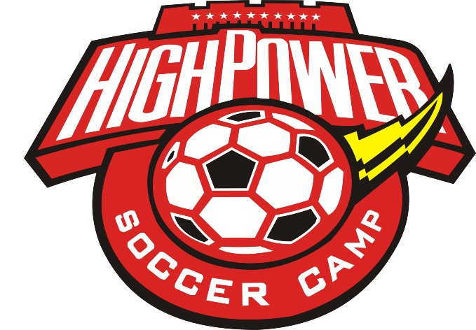
June 26th-30th
6-8:00pm Ages 5-12
Registration includes instruction, games, snack, backpack, soccer ball, t-shirt, & water bottle!
*Registration Cost: $10 per camper
*Family discount: $10 1st camper, $5 for each additional camper from same household

CAMP COACHES
Jay Riggleman: Boys Varsity Soccer, Sodus High School
Mike Barnes: Girls Varsity Soccer, Sodus High School
Al Ferland: Boys Varsity Soccer, Williamson High School
Jeff VanHoover: Boys JV Soccer, Williamson High School

Hosted by Bible Baptist Church of Sodus
6181 Ridge Rd. 315-483-9886 www.biblebc.org

Registration Options
- Complete form and mail to BBC with check for *amount due payable to BBC with Soccer Camp on Memo line.
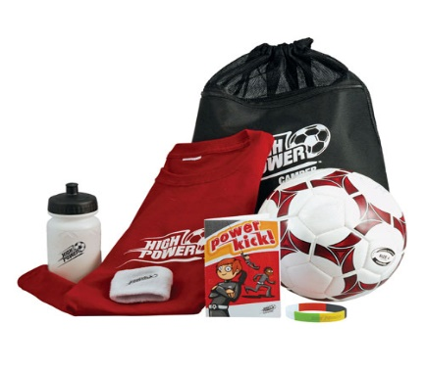
- Complete form and return with payment to BBC at one of the following walk-in registration times.
Walk-In Registration Times:
Saturday June 10th 9-11am Wednesday June 14th 6-7pm
Saturday June 17th 9-11am
Each camper must have a completed registration form!

High Power Soccer Camp Registration Form
June 26th-30th 2017 6-8:00pm

Camper Name ________________________ Age _____ Boy _____ Girl _____
Address ___________________________________________________________
T-Shirt Size: __ (S) __ (M) __ (L) Food Allergies: _____________________
Parent/Guardian ____________________________________________________
Phone Number ___________________ Email Address _____________________
Emergency Contact: ______________________ Phone: ___________________
Adults Authorized to Pick-Up Camper: __________________________________
Each camper needs a completed registration form!
Liability Release: I give the camper identified on this form permission to particpate in the High Power Soccer camp to be held at Bible Baptist Church of Sodus (“BBC”) on June 26-30, 2017. FOR MYSELF, SPOUSE, AND CHILD, I KNOWINGLY AND FREELY ASSUME ALL SUCH RISKS, both known and unknown, EVEN IF ARISING FROM THE NEGLIGENCE OF THE RELEASEES or others, and assume full responsibility for my child’s participation.

Emergency Medical Treatment: I understand and agree that BBC does not have medical personnel available at the location of the camp activities. I hereby grant BBC permission to authorize emergency medical treatment, if necessary, and to transport Camper to an appropriate facility to receive emergency medical treatment, and that such action shall be subject to the terms of this Agreement. I understand and agree that BBC assumes no responsibility for any injury or damages which might arise out of, or in connection with, such authorized emergency medical treatment.

Photo/Media Release: I give permission for photographs/videos taken of me/my child/ward while participating in the Soccer Camp to be used in marketing/public relations material in the promotion of Soccer Camp.

I acknowledge that I have read this registration form in its entirety and agree to its stipulations.

Signature: _____________________________________ Date ___________
Printed Name: _________________________________

Please mail completed registration form(s) including *payment due (see cover page) to:
Bible Baptist Church, 6181 Ridge Road, Sodus, NY 14551. Checks should be made payable to BBC with “Soccer Camp” written on the memo line.
Payment Received (Camp Registrar use only) Check _____ Cash ____ Date ____________

